**PROJECT 1 NAME:**

**TALKING TOM**

**Description:** Talking Tom is a fun and interactive app where users can talk to a cute virtual cat named Tom. When the user speaks into the device's microphone, Tom responds with a funny voice, repeating what was said. The app uses speech recognition and text-to-speech technology to create an engaging and entertaining experience for users of all ages.

**Features:**

* **Speech Recognition:** Captures the user's voice input.
* **Text-to-Speech:** Converts the captured text into speech, making Tom "talk."
* **Easy to Use:** Simple interface with a large button to start the interaction.

**How to Use:**

1. Open the app and tap the "click here to speak" button.
2. Speak into the microphone, and watch Tom come to life as he repeats your words.

**Target Audience:** Kids, families, and anyone who enjoys interactive and entertaining apps.

**APP:**



**PROJECT 2 NAME:**

**TIMER APP**

**DESCRIPTION:**

The Remaining Time app is designed to help users manage their time effectively by providing a clear visual representation of the time remaining for various tasks, events, or activities. This app is ideal for students, professionals, and anyone who wants to stay on top of their schedule and deadlines. With a user-friendly interface and customizable timers, the Remaining Time app ensures you never lose track of your time.

**Features:**

* **Notifications:** Get notified when a timer is about to finish or has finished.
* **User-Friendly Interface:** Simple and intuitive design for easy navigation and use.

**How to Use:**

1. Tap "Start" to begin the timer.
2. Receive notifications when your timer is nearing completion or has ended.

**Target Audience:** Students, professionals, homemakers, and anyone looking to manage their time more effectively.

**APP:**

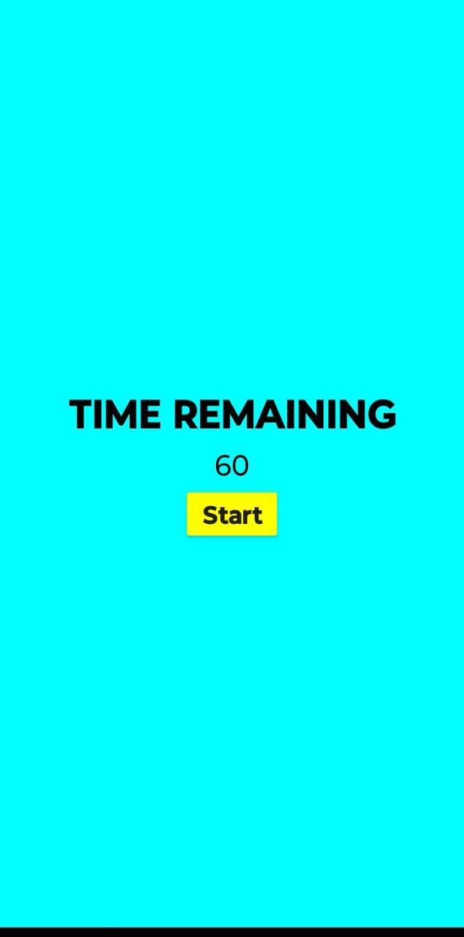

**TEAM NAME:**

**VISIONARY VORTEX**

**TEAM MEMBERS:**

**NETHRA S - CSE156**

**SABITHRA M - CSE202**

**NITHYASRI S - CSE164**